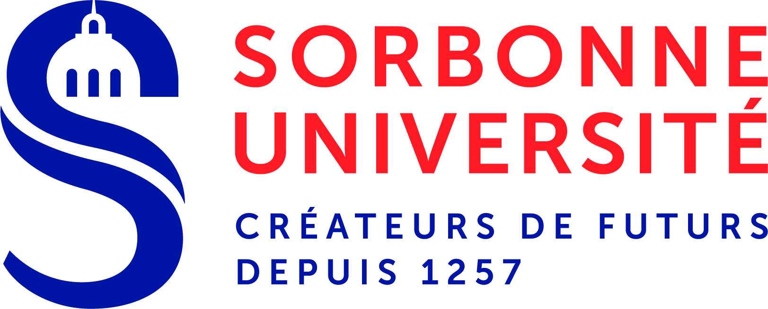 | Aymeric Spiga |  |  |  | 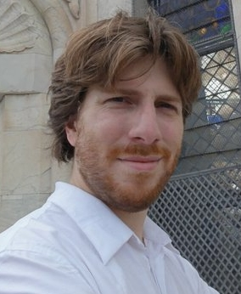
 | Maître de conférences
 | Sorbonne Université  Laboratoire de Météorologie Dynamique |  | Paris, F-75005  Phone: +33 1 44 27 28 47
aymeric.spiga@sorbonne-universite.fr
http://www.lmd.jussieu.fr/~aslmd/

Education:
Université Pierre et Marie Curie (now Sorbonne Université) |  | Ph.D, Mesoscale Modeling of Martian Atmospheres, 2008
Université Pierre et Marie Curie (now Sorbonne Université) |  | M.S., Atmosphere, Ocean and Climate Dynamics, 2005
École Polytechnique / École des Ponts et Chaussées |  | B.S. / M.S. Quantum Physics, Environmental Science, 2004
Professional Experience:
- Habilité à diriger des recherches (Senior Associate Professor), Sorbonne Université  - Maître de conférences (Associate Professor), Sorbonne Université  - Post-doctoral research fellow, Open University (UK) |  |  |  |  |  | 2016-now  2010-now  2009-2010
Space mission Experience:
- Participating Scientist InSight (2018-now), leading InSight Atmospheres Science Theme Group
- Co-Investigator SEIS / InSight (2013-now)
- Co-Investigator ACS / ExoMars Trace Gas Orbiter (2014-2016)
- Co-Investigator DREAMS / ExoMars Schiaparelli (2011-2016)
- Co-Investigator OMEGA / Mars Express (2005-2013)
Honors, Awards, Professional Achievements:
- 2017-2022 – Selected Member of Institut Universitaire de France (top 2% of associate professors in France)
- 2013-2015 – Délégation CNRS (half-teaching time paid for by CNRS)
- 2009 – Best PhD in Earth and Space Science awarded by Airbus Foundation
Selected Publications:
Dr Aymeric SPIGA is author of 73 published papers [h-index = 24], 2 accepted papers and 9 submitted papers

- A. Spiga, S. Guerlet, E. Millour, M. Indurain, Y. Meurdesoif, S. Cabanes, T. Dubos, J. Leconte, A. Boissinot, S. Lebonnois, M. Sylvestre, and T. Fouchet. Global climate modeling of Saturn's atmosphere. Part II: Multi-annual high-resolution dynamical simulations. Icarus, 335:113377, 2020.

- M. Lefèvre, A. Spiga, and S. Lebonnois. Mesoscale modeling of Venus' bow-shape waves. Icarus, 335:113376, 2020.

- A. Spiga, D. Banfield, N. A. Teanby, F. Forget, A. Lucas, B. Kenda, J. A. Rodriguez Manfredi, R. Widmer-Schnidrig, N. Murdoch, M. T. Lemmon, R. F. Garcia, L. Martire, Ö. Karatekin, S. Le Maistre, B. Van Hove, V. Dehant, P. Lognonné, N. Mueller, R. Lorenz, D. Mimoun, S. Rodriguez, É. Beucler, I. Daubar, M. P. Golombek, T. Bertrand, Y. Nishikawa, E. Millour, L. Rolland, Q. Brissaud, T. Kawamura, A. Mocquet, R. Martin, J. Clinton, É. Stutzmann, T. Spohn, S. Smrekar, and W. B. Banerdt. Atmospheric Science with InSight. Space Science Reviews, 214:109, 2018.

- A. Spiga, D. P. Hinson, J.-B. Madeleine, T. Navarro, E. Millour, F. Forget, and F. Montmessin. Snow precipitation on Mars driven by cloud-induced night-time convection. Nature Geoscience, 10:652--657, 2017.

- M. Lefèvre, A. Spiga, and S. Lebonnois. Three-dimensional turbulence-resolving modeling of the Venusian cloud layer and induced gravity waves. Journal of Geophysical Research (Planets), 122:134--149, 2017.

