Mni-project :

Microphysics and radiative effects of cold clouds in polar regions

M2 MOCIS : Numerical Modeling course
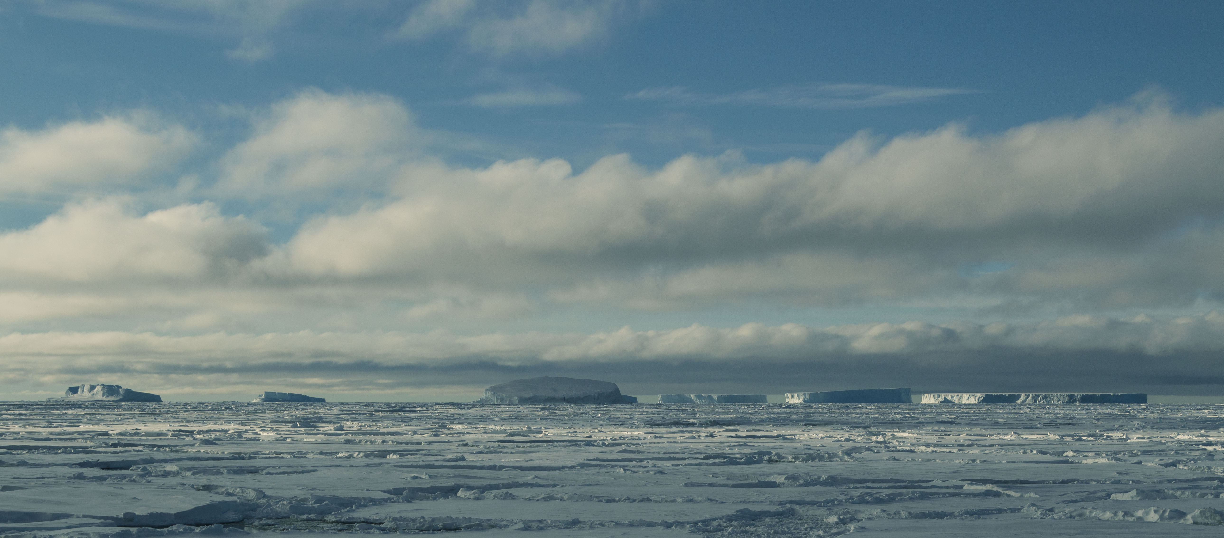

1. Context

Among the major shortcomings of climate models is a poor representation of clouds over the Southern and Arctic Oceans (Bodas-Salcedo et al. 2014, Kay et al. 2016). Clouds in those regions are either fully composed of ice crystals or are so-called ‘mixed-phase’ clouds, i.e. clouds composed of ice and ‘supercooled’ liquid droplets that form and persist at temperatures below zero Celsius.
Liquid droplets significantly controls how much the Earth surface receives radiative energy. Compared to ice crystals, they tend to reflect more solar energy towards space and at the same time, they enhance the cloud infrared emission towards the ground surface. The liquid water content in cold clouds have thus strong impacts on near-surface temperatures in polar regions and on the melting of sea ice and ice shelves.

The aim of this master project is too assess the sensitivity of the climate represented by LMDZ to the parameterization of cold clouds.

2. Sensitivity tests in 1D and 3D configurations

The representation of clouds in LMDZ results from a complex chain of parameterizations but two of them are of particular interest for cold clouds at high latitudes :
- the parameterization of the liquid water fraction in cold clouds (which directly controls their phase and radiative effect)
- the parametrization of the ice fallspeed velocity, which determines the precipitation flux and the lifetime of a clouds.

At negative Celcius temperatures, the liquid fraction of the mass of cloud condensates is estimated as follows :

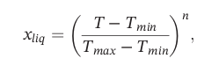

where Tmin, Tmax and n are three parameters that can be modified in the physiq.def file (they are named t_glace_min, t_glace_max and exposant_glace respectively). This calculation of the ice fraction (1-xliq) is performed in the function
modipsl/modeles/LMDZ/libf/phylmd/icefrac_lsc_mod.F90
The figure here below shows the evolution of the liquid fraction with temperature.

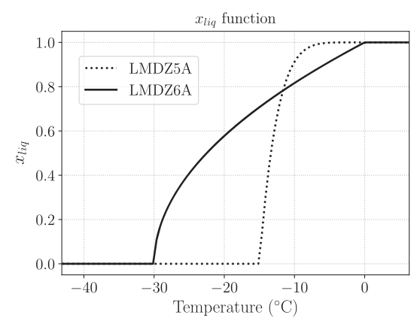

Figure : Liquid fraction x liq as a function of temperature used in
Versions 5A and 6A of LMDZ. Figure from Madeleine et al. 2020.

The fall velocity vm of ice crystals is parameterized as a function of the ice water content (IWC) following Heymsfield & Donner (1990) :
vm=FALLV*3.29*(IWC)^{0.16}
where FALLV is a tuning parameter (ffallv_lsc in physiq.def) that equals 0.8 by default.

At the beginning of the project, you will first assess the sensitivity of the simulation of clouds (vertical structure, phase, cover, mass, lifetime), surface radiative fluxes and surface precipitation to the above-mentionned parameters using the MPACE 1D case [Klein et al. 2009]. This idealized 1D case study consists in the simulation of a boundary-layer mixed-phase clouds above Barrow, Alaska. Please comment also on the vertical distribution of the liquide and ice phase in the model compared to remotely-sensed observations shown in Klein et al. 2009 (see their Fig. 6).

In a second step, you will assess how the representation of ice and mixed-phase clouds modifies the representation of the high-latitude climate in 2-year 3D LMDZ simulations. For this purpose, you may assess the sensitivity of the radiative fluxes and cloud radiative effect (CRE) at the surface and at the top of the atmosphere over the Southern and Arctic Oceans to the liquid/ice distribution and to the ice fallspeed velocity. You can also comment on changes of the near-surface temperature over the margins of the Greenland and Antarctic ice sheets.

References

Bodas-Salcedo, A., Williams, K. D., Ringer, M. A., Beau, I., Cole, J. N. S., Dufresne, J.-L., Koshiro, T., Stevens, B., Wang, Z., & Yokohata, T. (2014). Origins of the Solar Radiation Biases over the Southern Ocean in CFMIP2 Models, Journal of Climate, 27(1), 41-56. Retrieved Feb 8, 2021, from https://journals.ametsoc.org/view/journals/clim/27/1/jcli-d-13-00169.1.xml

Heymsfield, A. J., & Donner, L. J. (1990). A Scheme for Parameterizing Ice-Cloud Water Content in General Circulation Models, Journal of Atmospheric Sciences, 47(15), 1865-1877. Retrieved Feb 9, 2021, from https://journals.ametsoc.org/view/journals/atsc/47/15/1520-0469_1990_047_1865_asfpic_2_0_co_2.xml

Kay, J. E., L’Ecuyer, T., Chepfer, H. et al. (2016a): Recent Advances in Arctic Cloud and Climate Research, Curr Clim Change Rep 2: 159.
https://doi.org/10.1007/s40641-016-0051-9

Klein, S., and Coauthors, 2009: Intercomparison of model simulations of mixed-phase clouds observed during the ARM Mixed-Phase Arctic Cloud Experiment. I: Single-layer cloud. Quart. J. Roy. Meteor. Soc., 135, 979–1002, doi:10.1002/qj.416.

Madeleine, J.‐B., Hourdin, F., Grandpeix, J.‐Y., Rio, C., Dufresne, J.‐L., Vignon, E., et al. (2020). Improved representation of clouds in the atmospheric component LMDZ6A of the IPSL‐CM6A Earth system model. Journal of Advances in Modeling Earth Systems, 12, e2020MS002046. https://doi.org/10.1029/2020MS002046

